**Dr.Vithalrao Vikhe Patil College of Engineering, Ahmednagar**

**2.5.2: Mechanism to deal with internal/external examination related grievances is transparent, time- bound and efficient.**

**Documents for mechanism to deal with internal/external examination related grievances are transparent, time- bound and efficient.**

External examination is a part of affiliated university. University had laid down the rules and regulation related to examination grievances and institute provides necessary support to candidate for this purpose. The links listed below provide the information about some of the cases of internal and external examination related grievances.

# INDEX

|  |  |  |
| --- | --- | --- |
| **Sr. No.** | **File Description** |  |
| 1. | University ordinances/circulars related to grievances related to marks obtained in University exams (Supply of Photo Copy of assessed answer books, revaluation of answer books) |  |
| 2. | Sample cases of marks change after applying offline for grievance related to marks obtained in University exams ( cases prior to introduction of online system) |  |
| 3. | Sample case of application to University regarding correction in name result/mark sheet |  |

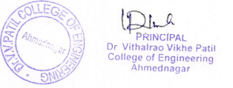

1